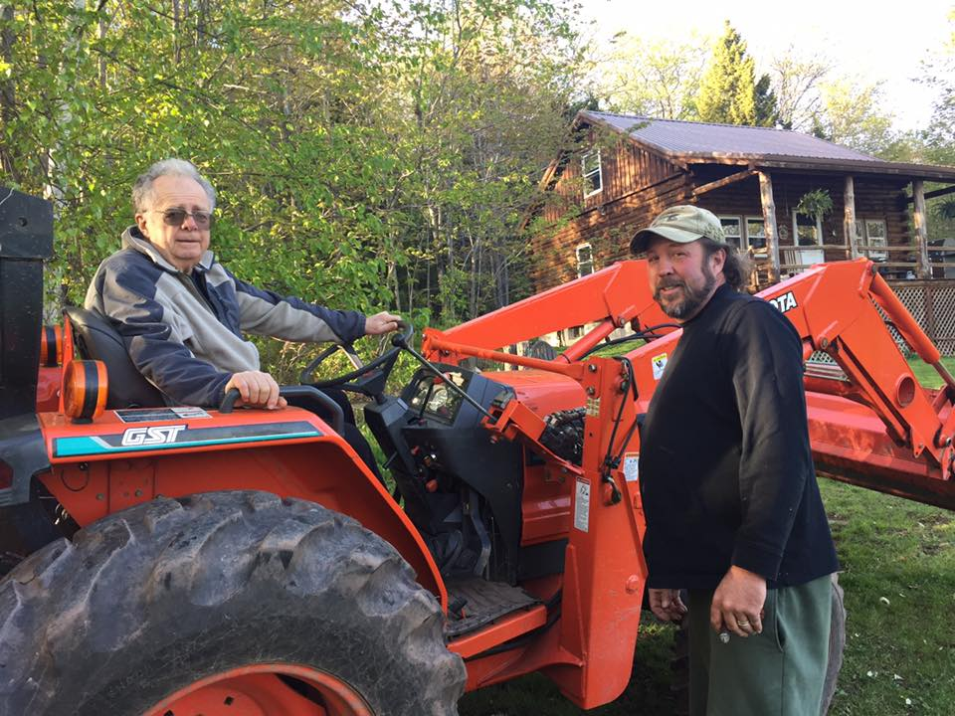
Haines Family Association, Inc.
www.hainesfamilyassociation.org

33rd ANNUAL FAMILY REUNION PICNIC
& MEETING

North Lake Pavilion

Saturday, September 7, 2019

Haines Family Members and Friends,

This year we are celebrating the accomplishments of 240 years that the Haines family has worked to improve the community of the mountaintop. Sadly, on July 19, we saw the passing of Anthony (Tony) Bucca. Tony was an active member of the community, loving father, husband and leader of fun at the reunion picnics. His presence will be missed, but his music will not be forgotten. Transitioning, at last year’s Board of Directors meeting, Aaron Van Dyke stepped up and took over the role of Vice President after Gibby stepped down. Gibby wanted to see a full slate of officers, and decided to focus on his role as the Treasurer. We are all grateful for Gibby’s continued service and the addition of Aaron to the executive body. Assuming Aaron’s role on the board of directors is Stephen Monteleone, welcome to the team Steph! Speaking of teams, we need a deeper bench. That means we need the next generation of family members to join the fun and share in their family’s storied history. This year we will be celebrating our 33rd annual family reunion and meeting, so let’s get together and celebrate our fortune. This year’s reunion will be held at the North Lake pavilion on Saturday, September 7, starting at 11am at the North - South Lake State Park. As always, all are welcome. It’s a celebration, so make it a point to come meet with family, friends, and neighbors to enjoy a beautiful day in the Catskills.
There are plenty of activities to fill your time with throughout the day if catching up, eating and cheer becomes tiresome. There are short hikes to incredible scenic vistas and longer ones that also take your breath. The lake itself provides swimming, boating, and fishing for all sorts of water enthusiasts. The beaches at both North and South Lake have lifeguards on duty that add another level of security for us parents and grandparents who understand that our little ones could always use an extra set of eyes to look out for their safety. If you want to strap a bicycle to your car, there are miles of roads and trails for your amusement. Bring a Frisbee, volleyball, or whiffle ball and bat and head to the field a short walk away for some good old-fashioned fun. The outdoors is at your disposal.
Once again, this year the Board of Directors will provide the protein for the picnic’s culinary diet in addition to Stewart’s ice cream. Instead of bring your own lunch, we will provide hamburgers, hotdogs, sausages, and chicken-you provide a side dish to pass and beverages of your choosing. However, there is one caveat, we just need an estimated head count so we know how much food to supply. What’s a party without people? RSVP to President, Anthony Coiro at coiroanthony68@gmail.com Phone: 518-589-7196, or Gibby Van Dyke, Treasurer at gvd.contracting@icloud.com Phone: 908-285-0145 by August 29, 2019. Remember, the reunion picnic is a time for family and friends to get together and enjoy the bonds we share. Bring photos and whatever you know about your family tree, and hopefully some of our attendees can further add to your knowledge
News: 2018-19 has been a busy time. We had work parties for cleanup and maintenance at the Aaron Haines Family Cemetery, and the Mountaintop Historical Society grounds. In addition, we organized a work party on June 22, 2019 to complete trash pickup along the Haines Family section of the Adopt-A- Highway program on Route 23A, just west of the Hunter town line. Dick Haines and Joe McGowan stopped by to see us off. The work party had a few extra hands this year which made for light work. Gibby and I were both pleased to have the skilled hands of Kelly Wells, Aaron Van Dyke and Sharon Van Dyke along to ease the burden. Thanks to all for the great company and your service to the community. Note: We will be looking for volunteers for our autumn highway cleanup. Please contact Aaron Van Dyke at 518-567-3099, or any of our other officers if interested.
Membership Dues and Donations
As you all know, community support and service does not come without a price tag. That is why your continued support is needed if we wish to provide our services to the mountaintop communities. Although our dues remain only $5 per year, the generous support given through your donations allows us to reach out where there is need. You can mail your dues and donations, or hand them in at the reunion. We need updated email addresses so we can send out information without spending dues money on postage and supplies. We are also looking to add members of families to our database so we can keep our reunion going for years to come. Please provide updated contact info for your children/heirs for inclusion.

Annual Board of Directors Meeting (To be determined)
If you have questions or comments, check out our newsletters, activity updates, or contact any of our officers or directors on our website at www.hainesfamilyassociation.org.
Tentative Slate of Officers and Directors for 2019-2020 is as follows: President – Anthony Coiro, Vice President- Aaron Van Dyke, Treasurer- George “Gibby” Van Dyke Jr., Secretary - Richard E. Haines, and Directors: Nancy McGowan, Linda Schultz, Harriet Bucca, George Van Dyke Sr., Sandy Palmer, Harold Palmer, Peg Fries, Sarah Van Dyke and Stephen Monteleone. If you would like to nominate someone, let us know now, or at our annual reunion meeting.
I hope to see all of you at our reunion barbeque picnic on Saturday, September 7 at the North Lake pavilion!
Sincerely,

Anthony Coiro
President
Haines Family Association, Inc.

